**Boorowa**

Parish Safeguarding Commitment: St Patrick’s Parish is committed to safeguarding and upholding the dignity and rights of all of our children and vulnerable people. If any parishioner has any concerns about the above, please email St Patrick’s Safeguarding officer-Carmel Barnes [boorowa.safeguarding@cg.org.au](mailto:boorowa.safeguarding@cg.org.au) or IPPS@cg.org.au

**CATHOLIC PARISHES BOOROWA/BINALONG-GALONG**

(Frogmore, Hovell’s Creek, Kangiara, Murringo, Reids Flat, Rugby & Rye Park)

- Part of the Young Mission

69-71 Queen Street (Church) PO Box 30, BOOROWA 2586

**Office hours**: Wednesday 9am-3pm Friday 9am -3pm

**Phone:** 0438 753 030 **e-mail:** [boorowa@cg.org.au](mailto:boorowa@cg.org.au) **Website** – [www.cg.org.au/boorowa](http://www.cg.org.au/boorowa)

Fr Jiss Sunny –Young Phone 6382 2222

Deacon Patrick Whale **Mob:** 0429 463 583

***We Acknowledge the Traditional Custodians who have walked upon and cared for this land for thousands of years. We acknowledge the continued deep spiritual attachment and relationship of Aboriginal and Torres Strait Islander Peoples to this country and commit***

***ourselves to the ongoing journey of reconciliation.***

SUNDAY MASS TIME

Sunday 5.00pm (Church)

WEEKDAY SERVICES

TUESDAY: 10.00am Adoration of the Blessed Sacrament with Rosary- 11.00am Communion Service with Liturgy of the Word (Church)

WEDNESDAY: 11.00am Liturgy of the word with Communion (Hospital)

THURSDAY: 11.00am Communion Service with Liturgy of the Word (Burrowa house)

FRIDAY: 12.30pm Communion Service with Liturgy of the Word Mass (Church)

RECONCILIATION (SACRAMENT OF PENANCE) Sunday at 4.30pm, or any time by appointment

COMMUNITY ROSARY: 4.30pm Sunday

MARRIAGES: By appointment, giving at least 6 months’ notice

BAPTISM: Sunday Night Vigil Mass - please email Parish Office for further particulars

**Binalong/Galong**

SUNDAY MASS TIMES

BINALONG Liturgy of the Word with Holy Communion 10.00am

Mass on the 4th Sunday 10.00am

GALONG MONASTERY

Sunday 9.00am Mass

Tuesday Wednesday Thursday Friday and Saturday 9.00am Mass

Reconciliations: anytime by appointment

**ROSTERS for the week of;**

***17/8/25***

**BOOROWA:**

**Reader –** Felicity McGrath

**Prayers of the Faithful** – Finn Corkhill

**Altar Serving** – Tom & Belinda Lawler

**Offertory**- Julie & Raymond Poplin

**Flowers**- Teena McGrath

**BINALONG:**

**Reader –** Robyn Sykes

**Church Cleaning –** Colleen Glover

***24/8/25***

**BOOROWA:**

**Reader** – School Mass

**Prayers of the Faithful** – School Mass

**Altar Serving**- School Mass

**Offertory**- School Mass

**BINALONG:**

**Reader –** Robyn Sykes

**Church Cleaning –** Colleen Glover

**DIRECT CREDIT**



1st COLLECTION:

Goes to supporting the priests & retired priests

If you would like to contribute, please contact Parish office via Email or Phone for account details. Thankyou

2nd COLLECTION:

Pays for costs for running the Parish

WEEKLY PLANNED GIVING Tax Receipts



If you would like to contribute, please contact Parish office via Email or Phone for account details. Thankyou

Please add name & add envelope number.

It is very important that individuals put the Reference information in, that way money can be allocated

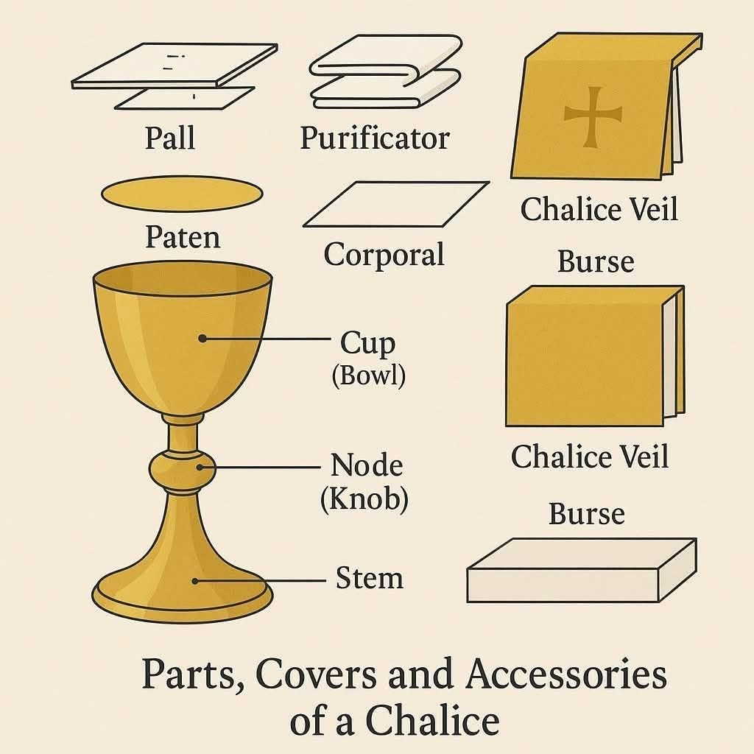

correctly.

The Boorowa St Vincent de Paul society would like to thank our wonderful parish community for your generous donations to our food pantry.  
Through your efforts we have been able to assist many vulnerable and disadvantaged families in our community.  
Your ongoing support, would be much appreciated so we are able to continue this great work in the future.  
Thank you again  
**Boorowa conference   St Vincent de Paul.**



